**PFUN Project Report:**

**Horse Betting Game**

*Muhammad Khubaib Mukaddam (07218)*

*Owais Aijaz (07610)*

*Hammad Sajid (07606)*

***Introduction:***

Our **"horse race betting game"** includes a random number of horses based on the programmer's preference and need, as well as the option to wager on a single horse. If the user's chosen horse wins, the betted sum rises by three times, whereas if the horse loses, the user loses the whole amount. It's worth noting that our program isn't hardcoded, nor does it follow a precise pattern that may enable the user to win all of the time; instead, we utilized Python's "random" function to avoid any set order.

If a user chooses a "blue” horse and lays a bet of **"x,"** the user will gain **"3*x"** if the blue horse wins, but if the user loses, he or she will lose the whole betted sum.

The objective of this report is to give detailed instruction on the functions that have been utilized, as well as a succinct overview of the program.

***Modules used:***

* Tkinter
* Random
* Time

***User-defined Functions:***

* start_game
* move_horses
* check_winner

***Working:***

The first few lines of code are simple, printing the pattern immediately in the console to make the game seem more dynamic and well-designed from the start, capturing the user's interest. The output of these few lines has been illustrated below.

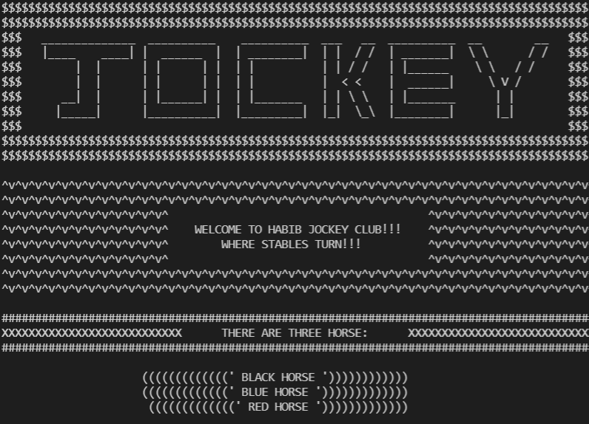

Next, the program takes input from the user regarding which horse will the user choose out of “black”, “blue”, and “red” horse. Then the program will ask the user to place a bet between 500 to 10,000. If the amount is less than 500 or more than 10,000 then the program will retake the input from the user and will continue this process until a valid input fulfilling all the conditions is provided.

The next few lines import some built-in python functions that include **“tkinter”**, **“time”**, and **“random”**. Tkinter is basically a framework that provides python users with a much simpler way to create GUI elements using widgets found in it. Tk widgets can be used to construct buttons, menus, data fields, etc. in Python applications. This Tkinter function allows us the use of “**canvas**”, the main widget that creates our GUI that appears in front of the screen. The rest of the code between lines 133 to 188 has been coded in order to fix the geometry of our GUI, import horses, tracks, fonts, and crowd, adjust their geometries according to the requirement along with the use of canvas to further adjust the images. We have also utilized some other python functions like “**Label”**, **“Button”**,and **“Geometry”**. The GUI which appears as a result has been attached below.

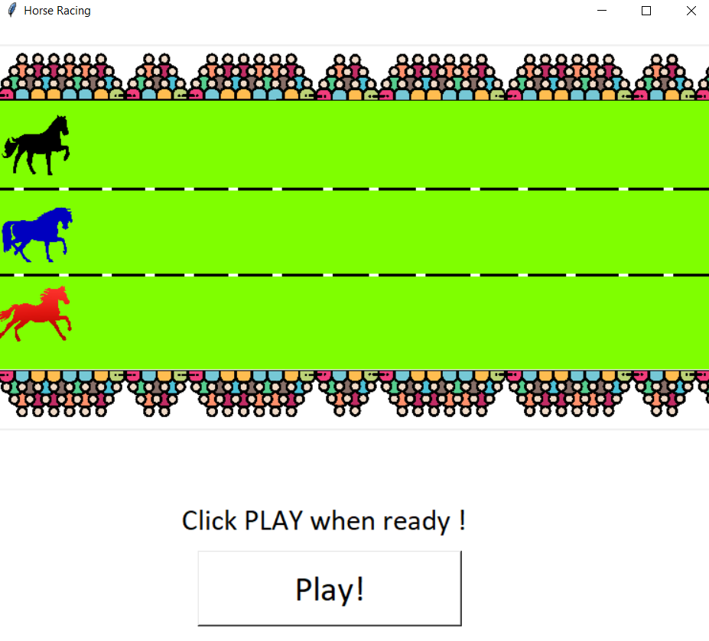

As soon as the user hits the play button, the horses start moving along the x-axis without having any effect on their y coordinate. As the variables along with their values keep changing over time during the movement, we have utilized the **“Global”** keyword in our code. As mentioned above, only the x-axis would change, and in order to keep this change totally random (so that no specific horse wins constantly), we used the **“random”** function of python that keeps on adding up the x-axis of each horse randomly and that increment itself is a limited specific value so that the game does not directly end when the user hits the play button. In order to keep a certain gap in each movement, we have also utilized **time.sleep()**.

In the end, as the horses move forward an **“imaginary line”** is present at the 670 value of x co-ordinate of the GUI which acts as the **“finish line”**. As soon as the x co-ordinate of any of the horses becomes >=670 then that specific horse will win. If all three or any two of them get the same x coordinates then the output will print **“TIE”,** else it will print the color of the winning horse along with the winning bet condition to return whether the user will lose all the amount or the amount will be tripled. For instance, if the blue horse wins the race when the bet placed on the blue horse was 500 then the following would be the output.

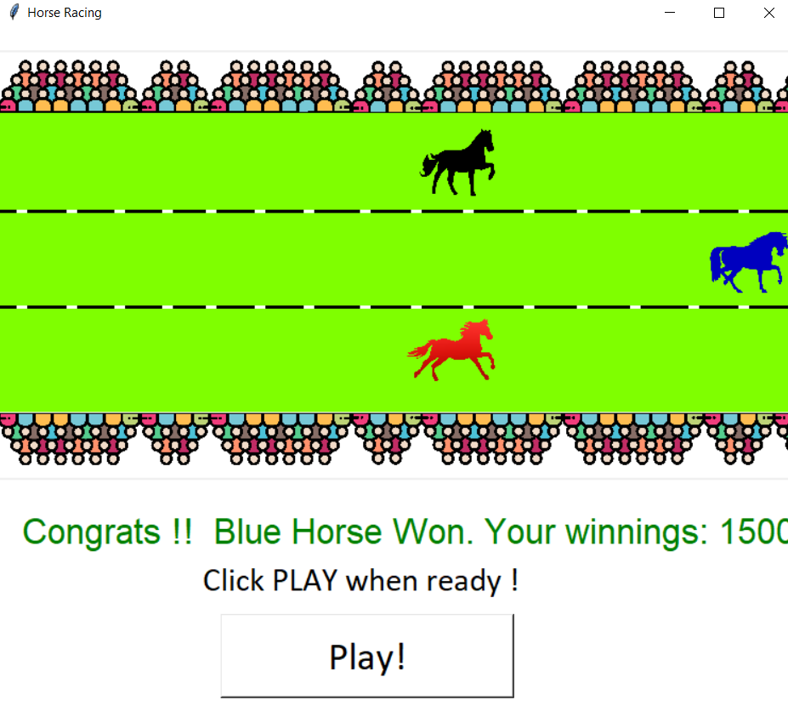

***Constraints:***

* Only red, blue or black horse should be selected.
* Betting amount should be in the range of 500-10000.